**JOMO KENYATTA UNIVERSITY OF AGRICULTURE AND TECHNOLOGY.**

**BSC.COMPUTER SCIENCE**

**DESIGN AND IMPLEMENTATION OF COMPUTER APPLICATION**

**MEMBERS.**

1. **Alfred Kahenya – SCT211-0023/2021**
2. **Sandrah Lewa – SCT211-0090/2022**
3. **Ian Karanja – SCT211-0462/2022**
4. **Rebecca Shirievo – SCT211-0538/2022**
5. **Favian Mokaya – SCT211-0022/2021**
6. **Joy Leila Kendi – SCT211-0091/2022**

**INTRODUCTION**

**The Bus Ticketing Management System** is a software solution designed to streamline and automate the process of ticketing and managing bus transportation services. It provides a centralized platform that enables bus companies, travel agencies, and passengers to efficiently handle various aspects of ticketing, seat allocation, schedule management, and payment processing.

The system offers a user-friendly interface that allows passengers to search for available bus routes, select seats, and book tickets online. It provides real-time information on bus schedules, departure and arrival times, and ticket availability. Passengers can make secure online payments through integrated payment gateways, ensuring a convenient and hassle-free ticketing experience**.**

**Functional requirements.**

The software of the bus ticketing system should be able to perform a range of essential functionalities to facilitate efficient ticketing and management processes. These functionalities include:

1. Ticket Booking: The software should allow passengers to search for available bus routes, select seats, and book tickets for their desired travel dates and times.

2. Seat Allocation: The software should automatically assign seats to passengers, considering their preferences and seat availability, to optimize seat utilization and minimize conflicts.

3. Schedule Management: The software should manage and display bus schedules, including departure and arrival times, locations, and any real-time updates or changes.

4. Payment Processing: The software should facilitate secure online payment processing for ticket purchases. It should integrate with payment gateways to accept various payment methods and ensure a smooth and secure transaction process.

5. Passenger Management: The software should store and manage passenger information, including contact details, ticket history, and preferences. It should enable easy retrieval and management of passenger records.

**Nonfunctional requirements.**

The basic software components that will be used for the bus ticketing system are as follows:

1. Development Environment:
   * IDE: Microsoft Visual Studio

* Programming Language: Visual Basic .NET
* Framework: .NET Framework

1. User Interface (UI):
   * GUI Toolkit: Windows Forms for creating the graphical user interface.

* Design: Basic WinForms controls for buttons, textboxes, labels, etc.

1. Database Management System (DBMS):

* Database: Microsoft Access.
* Data Access: ADO.NET for basic database connectivity.
* SQL Queries: Simple SQL queries.

Hardware components used include:

1. Server or Hosting Environment:

- Physical Server: Examples include Dell PowerEdge, HP ProLiant, or Lenovo

2. Computing Resources:

- CPU

- RAM: a minimum of 8GB RAM

- Storage: Solid-State Drives (SSDs) or Hard Disk Drives (HDDs) for storing the software, database, and associated data.

4. Client Devices:

- Desktop Computers, Laptops, Tablets, Smartphones

**Architectural design**

Designing an e-bus ticketing system involves several components to ensure efficiency, security, and user-friendliness. Below is a high-level architectural design for such a system:

1. User Interface:

- Mobile Application: An intuitive app for passengers to search for routes, check schedules, purchase tickets, and manage their accounts.

2. Backend Services:

- Authentication Service: Handles user authentication and authorization, ensuring secure access to the system.

- Ticketing Service: Manages ticket purchases, cancellations, and refunds.

- Route Management Service: Manages bus routes, schedules, and updates.

- Payment Gateway Integration: Facilitates secure online payments for ticket purchases.

- Customer Support Integration: Integration with customer support services for issue resolution and assistance.

3. Database Layer:

- User Database: Stores user information, including profiles, payment details, and booking history.

- Ticket Database: Stores information about ticket purchases, including type, price, date, and route.

- Route Database: Stores information about bus routes, stops, schedules, and any updates.

4. Integration with External Systems:

- Bus Fleet Management System: Integration with systems managing the fleet of buses to synchronize route and schedule information.

5. Security Measures:

- Implement login verification measures to secure sensitive data such as user credentials and payment information.

6. User Experience Considerations:

- Responsive Design: Ensure that the app is responsive and optimized for various devices.

- Intuitive Interface: Design a user-friendly interface with clear navigation and minimal friction for ticket purchasing and management.

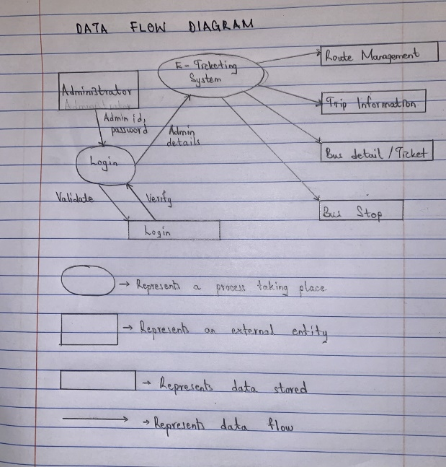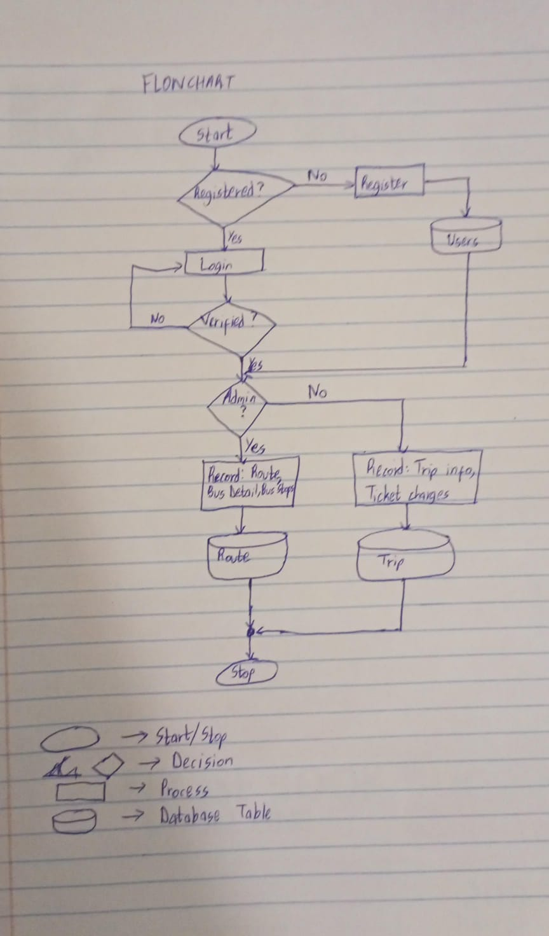

|  |  |
| --- | --- |
| **ACTIVITY** | **DURATION** |
| System Analysis | 1 week |
| System design | 1 week |
| System construction(coding) | 3 weeks |
| System testing and debugging | 1 week |
| System implementation | 1 week |
| Total Duration | 7 weeks |

**DATABASE DESIGN**

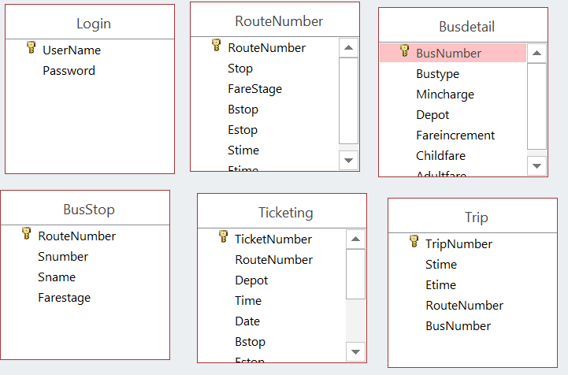

**UI/UX DESIGN**

